**IRIS TEMPLATE CREATION**

1. Run calling\_program.m and select an eye image from the folder input\_output suppose 001\_1\_1

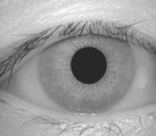

This in turn will create the following file by SEGMENTATION function

1. 001\_1\_1.bmp-houghpara.mat, define the Iris pupil position and iris position

2. 001\_1\_1.bmp-noise.jpg

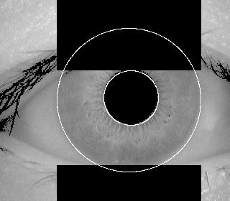

3. 001\_1\_1.bmpsegmented.jpg

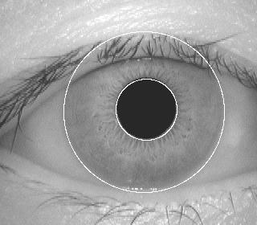

Now after normalization the following file are crate: by NORMALISEIRIS function

1. 001\_1\_1.bmp-polarnoise.jpg

D:\WORKS\Iris Recognition\CG\CG\input_output\001_1_1.bmp-polarnoise.jpg

2. 001\_1\_1.bmp-polar.jpg

D:\WORKS\Iris Recognition\CG\CG\input_output\001_1_1.bmp-polar.jpg

Now the following file is crate: by ENCODE function

1. 001\_1\_1.bmp-template.mat

2. 001\_1\_1.bmp-biometric-templete.jpg

D:\WORKS\Iris Recognition\CG\CG\input_output\001_1_1.bmp-biometric-templete.jpg

\*\* By this method we have to create two or more template for matching

For matching call matching.m

Which will take two template file for finding the hamming distance between them

If we select the template 001\_1\_1.bmp-templete.mat & 001\_1\_3.bmp-templete.mat

Then the hamming distance will be 0.2195

THE FUNCTINS AND THEIR CALLING FUNCTIONS AND OUTPUT

1. CALLING PROGRAM (CREATEIRISTEMPLATE: This function create the file -houghpara.mat)
2. CREATEIRISTEMPLATE (SEGMENTIRIS for segmentation, CIRCLECOORDS - returns the pixel coordinates of a circle defined by theradius and x, y coordinates of its centre.NORMALISEIRIS for Normalization)
3. SEGMENTIRIS (FINDCIRCLE: This function finds iris and pupil boundary using Canny Edge detection followed by Circular Hough Transform, FINDLINE :This function finds the coordinates of a line in an image using the

linear Hough transform and Canny edge detection, LINECOORDS - returns the x y coordinates of positions along a line)

1. FINDCIRCLE (CANNY: For edge detection, HOUGHCIRCLE : for finding circles in the image)
2. FINDLINE: it is requires detecting the top and bottoming eyelid and eye lashes.
3. NORMALISEIRIS - performs normalisation of the iris region byunwrapping the circular region into a rectangular block of constant dimensions. It was done by the Daugman’s rubber sheet model (ENCODE - generates a biometric template from the normalised iris region,also generates corresponding noise mask)
4. ENCODE - generates a biometric templatefrom the (polar\_array, polar\_noise) which is the output of the NORMALISEIRIS with the help of 1D log-Gabor filters(GABORCONVOLVE - function for convolving each row of an image with 1D log-Gabor filters)
5. MATCHING- it will take 2 tamplate.mat file and will find the hamming distance between them.